**Chapter 7**

**SNAPSHOTS**

**7.1 Initial View:**

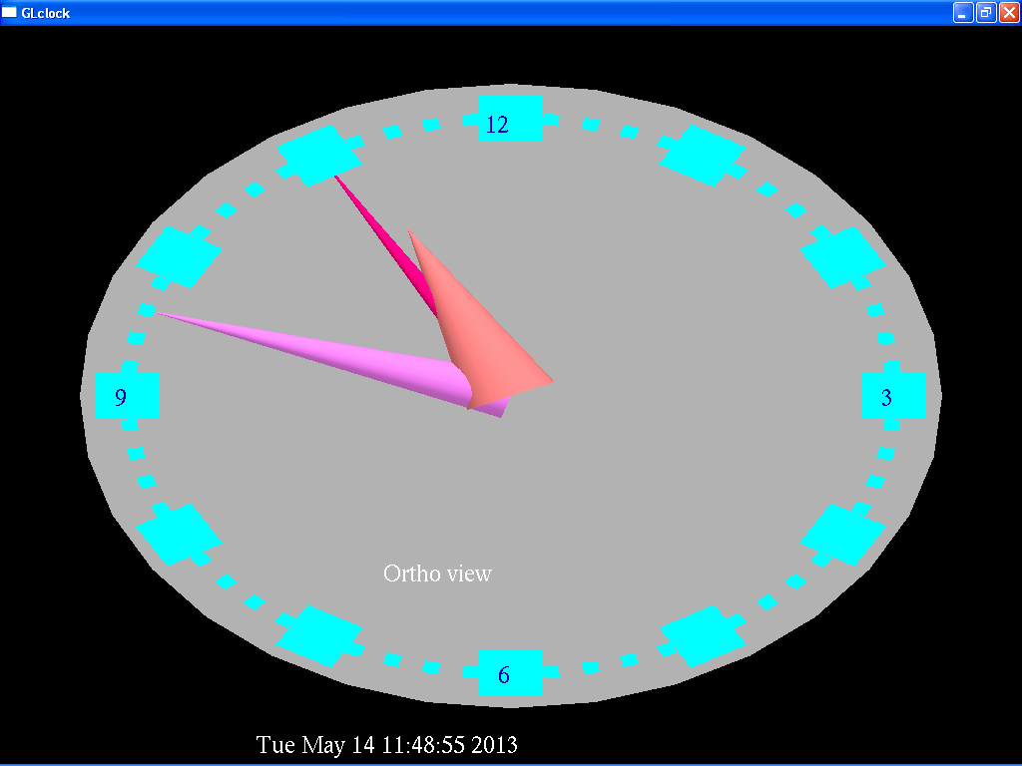

The snapshot above shows the Clock in Ortho view initially.

**7.2 Menu with options:**

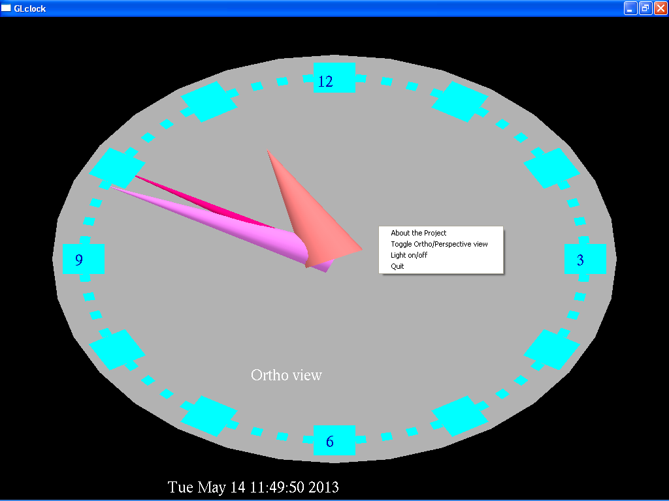

The snapshot above shows the menu containing different options.

**7.3 Ortho view:**



The snapshot above shows the Clock in Ortho view.

**7.4 Perspective view:**

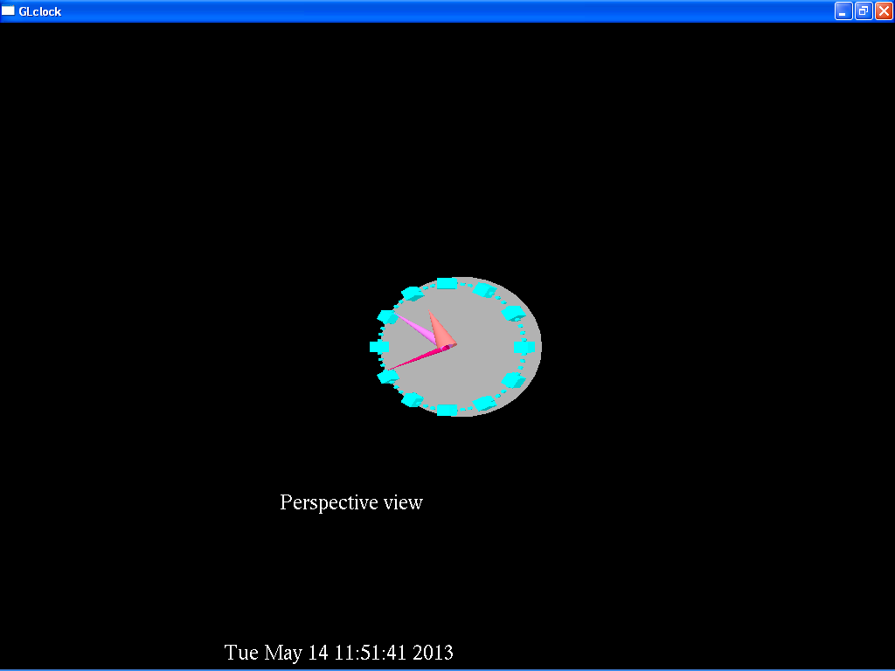

The snapshot above shows the Clock in perspective view. The user is able to toggle between these two views.

**7.5 Brightness ON:**

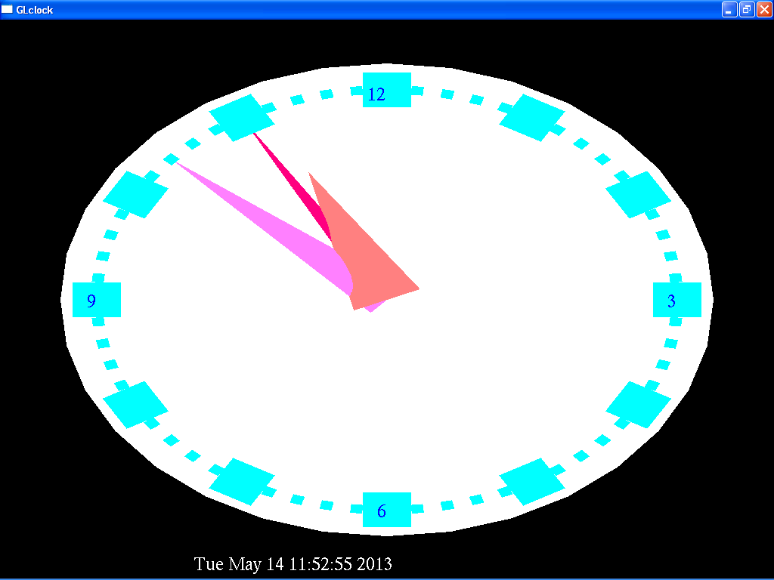

The snapshot above shows the Clock with brightness on.

**7.6 Brightness OFF:**

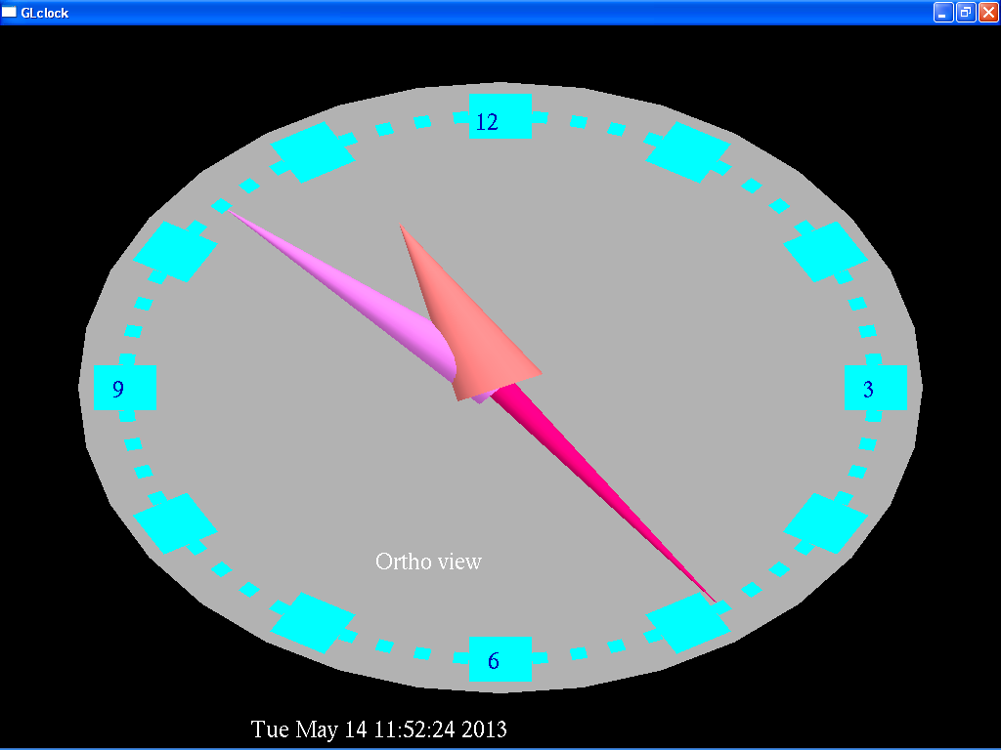

The snapshot above shows the Clock with brightness off. The user is able to adjust the brightness of the clock.

**7.7 Window with description of the project:**

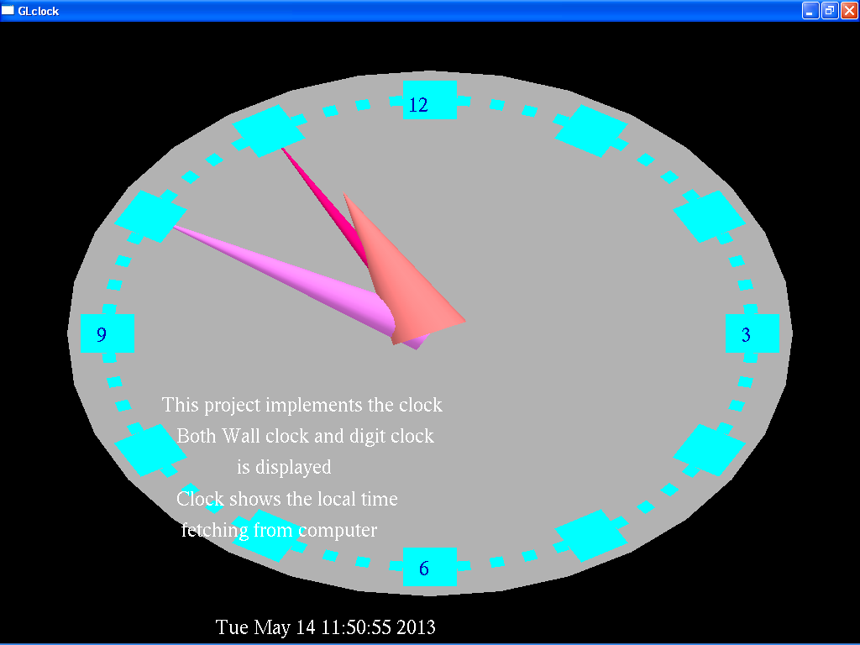

The snapshot above shows a short description about the project.